TITLE OF RESEARCH REPORT / DISSERTATION / THESIS

NAME OF CANDIDATE

DEPARTMENT WHERE CANDIDATE IS REGISTERED DAWOOD UNIVERSITY OF ENGINEERING AND TECHNOLOGY
KARACHI

YEAR OF SUBMISSION

TITLE OF RESEARCH THESIS WHICH HAS BEEN APPROVED BY THE FACULTY/ SENATE

NAME OF CANDIDATE

[THESIS] SUBMITTED IN [FULFILMENT/PARTIAL FULFILMENT] OF THE
REQUIREMENTS FOR THE DEGREE OF [NAME OF PROGRAM]

DEPARTMENT WHERE THE CANDIDATE IS
REGISTERED
DAWOOD UNIVERSITY OF ENGINEERING AND
TECHNOLOGY KARACHI

YEAR OF SUBMISSION

DAWOOD UNIVERSITY OF ENGINEERING AND TECHNOLOGY ORIGINAL LITERARY WORK DECLARATION
Name of Candidate: (NIC/Passport No: ) Registration/Enrolment No:
Name of Degree:

Title of Thesis (“this Work”):

Field of Study:

I do solemnly and sincerely declare that:

- I am the sole author/writer of this Work.
- This Work is original.
- Any use of any work in which copyright exists was done by way of fair dealing and for permitted purposes and any excerpt or extract from, or reference to or reproduction of any copyright work has been disclosed expressly and sufficiently and the title of the Work and its authorship have been acknowledged in this Work.
- I do not have any actual knowledge nor do I ought reasonably to know that the making of this work constitutes an infringement of any copyright work.
- I hereby assign all and every right in the copyright to this Work to the Dawood University of Engineering and Technology (“DUET”), who henceforth shall be owner of the copyright in this Work and that any reproduction or use in any form or by any means whatsoever is prohibited without the written consent of DUET having been first had and obtained.
- I am fully aware that if while making this Work, I have infringed any copyright whether intentionally or otherwise, I may be subject to legal action or any other action as may be determined by DUET.

Candidate’s Signature Date:

Subscribed and solemnly declared before,

Supervisor Signature Date:

Name:

Designation:

title

Is my own work and has not been submitted previously by me for taking my degree from the University
DUET Karachi (Name of University) Or anywhere else in the country/world.
At any time if my statement is found to be incorrect even after my Graduate the university has the right to withdraw my MS/PhD degree.

Name of Student:

Date:01/03/2021
title

Is solely my research work with no significant contribution from any other person. Small contribution/help wherever taken has been duly acknowledge and that complete thesis has been written by me.

I understand zero tolerance policy by HEC and University.

DUET Karachi (Name of University)

towards plagiarism. Therefore, I as an Author of the above titled thesis declare that no portion of my thesis has been plagiarized and any material used as reference is properly referred/cited.
I undertake that if I am found guilty of any formal plagiarism in the above titled thesis even after award of MS/PhD degree, the University reserve the right to withdraw/revoke my PhD degree and that HEC and the University has the right to publish my name on the HEC/University Website on which names of students are placed who submitted plagiarized thesis.

Student/Author Signature:

NAME: Naveed Ahmed

This is to certify that the research work presented in this thesis, entitled

title

Was conducted by Mr. _ name of student under the supervision of name of supervisor No part of this thesis has been submitted anywhere else for any other degree. This thesis is submitted to the Electronics Department of DUET Karachi
In partial fulfillment of requirements of the degree of Doctor of Philosophy in Field of
Power Electronics Subject
Name Name of student Department of dept University of Dawood University of Engineering & Technology Karachi

Student Name: Signature:

Examination Committee:

- External Examiner 1: Name. Designation and Office Address) Signature:

- External Examiner 2: Name. Designation and Office Address) Signature:

- Internal Examiner: Name. Designation and Office Address) Signature:

Supervisor Name Signature:

Name of Dean/HOD: Signature:

(Please delete this part): Abstract should not be more than 500 words.

For Abstract text use normal style. And for the title of the abstract use TOC 1 style.

(Please delete this part): Most theses have their subsection to convey appreciation to those who have been involved in the study.

For Acknowledgment text use Normal Style and for title of Acknowledgment use TOC 1 style.

ABSTRACT VII
ACKNOWLEDGEMENTS VIII
TABLE OF CONTENTS IX
LIST OF FIGURES XI
LIST OF TABLES XII
LIST OF SYMBOLS AND ABBREVIATIONS XIII
CHAPTER 1: HEADINGS 15
  - First Subtitle (heading 2, h 2) 15
    - Other subtitles (Heading 5, h 5) 15
WRITING STYLES AND NUMBERING 16
CAPTION BLOCKS METHOD IN MS WORD 2013. 17
  - Table-caption block 17
  - Figure-caption block 17
  - Equation-caption block 18
  - General-Caption block 18
TABLES 19
FIGURES 20
EQUATIONS 21
  - Equation-caption block 21
  - General-Caption block 21
REFERENCES 22
Appendix title (Heading7, h7) 23
LIST OF PUBLICATIONS AND PAPERS PRESENTED 24
Appendix title (Heading7, h7) 23
  - Appendix sub-title (Heading8, h8) 23
    - Appendix sub-sub-title (Heading8, h8) 23

(Please delete this part): This list contains the titles of figures, together with their page numbers, which are listed in the text. For e.g., figures in Chapter 3 are numbered sequentially: Figure 3.1, Figure 3.2.
For title of list tables use TOC 1 for style.

(Please delete this part): This list contains the titles of tables, together with their page numbers, which are listed in the text. The numbering system is according to chapter, for e.g.: tables in Chapter 3 are numbered sequentially: Table 3.1, Table 3.2.
For title of list tables use TOC 1 for style.

CC | : | Central canal
 | :
 | :

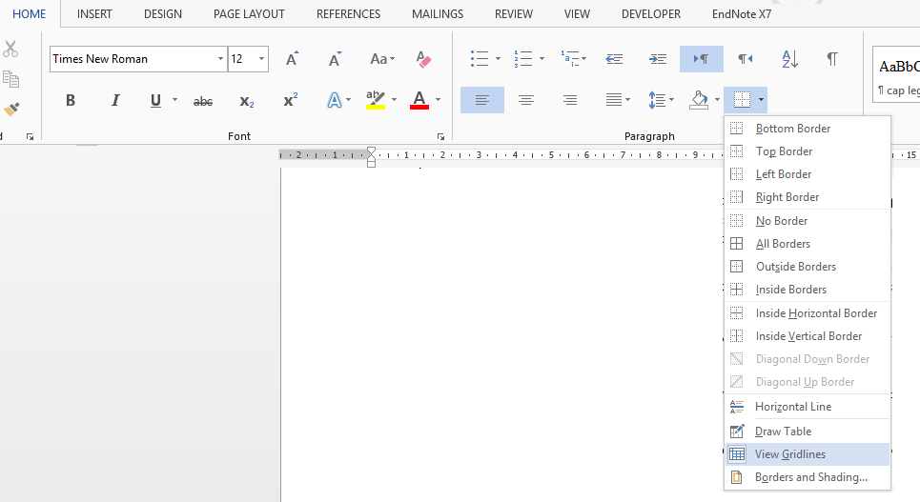 | To view this document properly, make sure that the View-Gridlines is  selected from Borders, in Paragraphs in Home menu.

These two pages are for illustration of Table of Contents and List of Figures, please delete entire pages.

CHAPTER 1:

HEADINGS

Chapters should be numbered with “chapter number”. 1. Use Heading 1 or h 1 for title and for table of content TOC 1 must be used.

1.1 First Subtitle (heading 2, h 2)

First topic in each chapter should numbered with “chapter number”. 1. Use Heading 2 or h 2 for title and for table of content TOC 2 must be used.

Second Subtitle (Heading 3, h 3)

For first subtopic in each chapter use Heading 3 or h 3 for title and for table of content TOC 3 must be used

Third Subtitle (Heading 4, h 4)

For second subtopic in each chapter use Heading 4 or h 4 for title and for table of content TOC 4 must be used.

Other subtitles (Heading 5, h 5)

For other subtopics in each chapter use Heading 5 or h 5 for title, and number them with (a), (b),… and for table of content TOC 6 must be used1.

  - Sample of footnote.

WRITING STYLES AND NUMBERING

The body of the text should be typed with double spacing. Single-spacing is only permitted in tables, long quotations, footnotes, citation and in the bibliography. Beginning of the first line of each paragraph should have 0.5 cm indentation.

For making numbered lists use “numbered lists style “and for bulleted list use “Bullet list” style. For both of them you will have 1 cm indention.

Numbered list example

Bullet list example

For explanation under bullet or numbered list use “indent” style which start a paragraph with 1.4 cm indention.

Do not change on Normal or text style because this is the base style for others so any change will affect other styles as well

CAPTION BLOCKS METHOD IN MS WORD 2013.

Caption blocks CBs are formatted-borderless tables. The method presented here uses CBs, to insert and manage figures, tables, and equations. This method is particularly useful in theses and dissertations, because greater precision is needed to manage the placement process. A very important feature of CBs method is that it keeps the captions attached together with its corresponding figure, table, and equation. Consequently, makes it easy to move the caption and the figure as one block if needed. 2 Four caption blocks have been created and are ready to be integrated into MS Word building blocks:

Table-caption block

Table-caption block, a block consists of two rows; the lower is for the table and the upper is for the numbered caption.

Table 3-1:

Figure-caption block

Figure-caption block, a block consists of two rows; the upper is for the figure and the lower is for the numbered caption.

Figure 3-1:

  - Some other methods use text boxes to insert figures and tables in MS Word. Text boxes should be avoided. For few reasons:

- Text boxes placement can be unpredicted.
- Text boxes do not allow you to properly use cross-references and fields within them
- Text boxes are independent of the caption, i.e. if you decide to move or realign your figures, you must remember to do so for each text box as well

Equation-caption block

Equation-caption block, a block consists of two columns; the left column is for the equation and the right is for the numbered caption.

Type equation here. | 3-1

General-Caption block

General caption block, with empty left side cell. Anything can be inserted in the left cell. This block is suitable for Mathtype and similar objects.

3-2

TABLES

Tables are printed within the body of the text at the center of the frame and labeled according to the chapter in which they appear. Thus, for example, tables in Chapter 2 are numbered sequentially: Table 2.1, Table 2.2.

The label should be placed above the table itself and has the following format:

Table 2.1: Short Title

If the table occupies more than one page, the continued table on the following page should indicate that it is a continuation: for example: ‘Table 2.7 continued’. If the table contains a citation, the source of the reference should be placed below the table.

To insert label above a table, click “Insert Caption” under the “References” tab and select “Table” in the dropdown list. Click on “Numbering” and tick the “Include chapter number” and select “period (.)” as separator. When done, click “Update Table” to update the List of Tables. If you are using DUETThesis template you can press ‘t’ then F3 to insert a caption block in the desired position.

Table 4-1: example

Heading | Heading
Test | Text

FIGURES

Figures, like tables are printed within the body of the text at the center of the frame and labelled according to the chapter in which they appear. Thus, for example, figures in Chapter 3 are numbered sequentially: Figure 3.1, Figure 3.2.

Figures, unlike text or tables, contain graphs, illustrations or photographs and their labels are placed at the bottom of the figure rather than at the top (using the same format used for tables). If the figure occupies more than one page, the continued figure on the following page should indicate that it is a continuation: for example: ‘Figure 3.7, continued’. If the figure contains a citation, the source of the reference should be placed at the bottom, after the label.

To insert label below a figure, click “Insert Caption” under the “References” tab and select “Figure” in the dropdown list. Click “Update Table” to update the List of Figures. If you are using DUETThesis template, you can press ‘f’ then F3 to insert a caption block in the desired position.
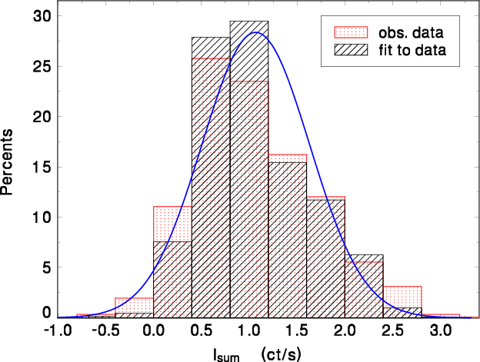

Figure 5-1: Example

EQUATIONS

Equation-caption block

Equation-caption block, a block consists of two columns; the left column is for the equation and the right is for the numbered caption.

Type equation here. | 6-1

General-Caption block

General caption block, with empty left side cell. Anything can be inserted in the left cell. This block is suitable for Mathtype and similar objects.

6-2

REFERENCES

(Please delete this part): All works, or studies referred to in the research report/dissertation/thesis in the form of quotations or citations must be included in the references. The references should be written consistently in the American Psychological Association (APA) format or in another format approved by the faculty.

Each reference should be written in single spacing format and a double space should be left between references. This list of references should not be numbered.

Use Reference style.

Examples:

In text format: (Angamuthu & Ramalingam, 2011)

Buchwalow, I. B., and Böcker, W. (2010). Immunohistochemistry: basics and methods.
Berlin: Springer Verlag.

Caamaño-Tubío, R. I., Pérez, J., Ferreiro, S., and Aldegunde, M. (2007). Peripheral serotonin dynamics in the rainbow trout (Oncorhynchus mykiss). Comparative Biochemistry and Physiology Part C: Toxicology & Pharmacology, 145(2): 245- 255

Cakir, Y., and Strauch, S. M. (2005). Tricaine (MS-222) is a safe anesthetic compound compared to benzocaine and pentobaritol to induce anesthesia in leopard frogs (Rana pipiens). Pharmacological Reports, 57: 467-474.

Cameron, A. A., Plenderleith, M. B. and Snow, P. J. (1990). Organization of the spinal cord in four species of elasmobranch fishes: cytoarchitecture and distribution of serotonin and selected neuropeptides. The Journal of Comparative Neurology, 297: 201-218

APPENDIX TITLE (HEADING7, H7)

Appendices consist of additional illustration of data sources, raw data and quoted citations which are too long to be placed in the text. The appendix supports the written text of the research report/dissertation/thesis. Research instruments such as questionnaires, maps or computer programs are parts of appendix too.

Appendices can be divided into Appendix A, B, C. Each appendix use Heading 7 or h 7 for title and for table of content TOC 7 must be used.

A.1 Appendix sub-title (Heading 8, h 8)

For second subtopic in each appendix use Heading 8 or h8 for title and for table of content TOC 8 must be used.

Appendix sub-sub-title (Heading 8, h 8)

For second subtopic in each appendix use Heading 9 or h 9 for title and for table of content TOC 9 must be used.

This page is optional; if you do not have any appendices, delete the entire page.

LIST OF PUBLICATIONS AND PAPERS PRESENTED

Published works as well as papers presented at conferences, seminars, symposiums etc. pertaining to the research topic of the research report/ dissertation/ thesis are suggested being included in this section. The first page of the article may also be appended as reference. For table of content TOC 1 must be used.

24

